Soil vs Dirt
There is a big difference between soil and dirt. They are different because of what is in them, what they are used for and where you can find them.
An easy way to explain it is this: Dirt is soil, but it is not where it should be. For example, you walked through your garden while it was raining and some soil stuck under your boots. The moment you entered the house, the soil under your boots is now called dirt. That is because it is no longer in the ground where it should be.
You can’t grow plants in dirt. They will not survive. The soil is the perfect place for growing plants. That is why dirt is completely useless while the soil is important to gardeners.
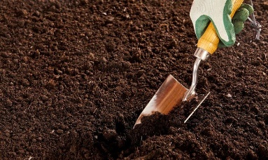
soil

Understanding Soil
The soil is composed of living and nonliving matter. It may contain nutrients, minerals, small living animals, water, dead organic matter, earthworms and other important things needed to make plant growth.
The quality of soil varies depending on geographical area. It may have different looks, chemical makeup, structure, color, and texture.
Soil is generally perfect for gardening. When you can see earthworms in the soil, it is a good sign of a fertile ground area where you can grow plants. Worms cannot survive in the dirt.

Understanding Dirt
Dirt is usually silty and rocky. Dirt is dead soil. It is void of any nutrients that plants need to grow. One sign that it is dirt and not the soil is when you add water to it. Dirt, when added to water, will not pack together well. It is not able to hold plants. That is why it is not good for planting.
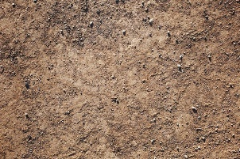
Dirt

How Soil Becomes Dirt
In simple terms, the soil is what you can generally find on the surface of the earth. Dirt, on the other hand, is soil that has been taken out of its natural environment. This could be a result of water run-off, volcanic eruption, and other natural and human factors.
The human factor is something we can control. One good example of how soil becomes dirt is when you dig in your backyard and transport the soil to another location. Without the correct steps, the soil could lose its natural makeup in the process and may no longer be able to support plant life.
Soil also becomes dirt when it loses its ability to support plant growth. A good example of this is the result of pollution. The soil in the city contains plenty of manmade materials including plastics and broken glass, burned clinkers, construction waste and garbage fill among others. While the soil is left to its natural environment, it is now full of pollutants. Plants cannot grow healthily in polluted soil. In this case, it is safe to call that soil, dirt. 