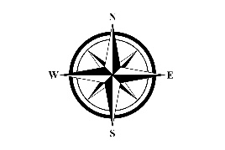
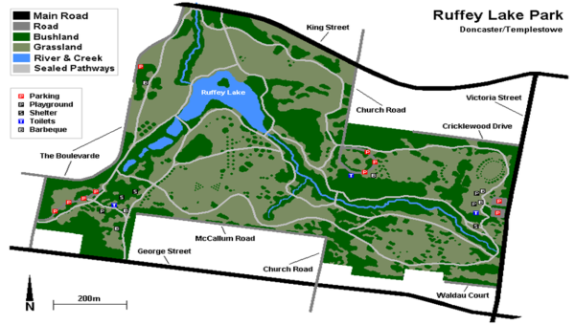
Follow the directions to find the hidden message. Write the letter you find for each step below to find the mystery word. Treasure
Q
R
E
s
U
A
E
R
T
- Find the letter North of Ruffey Lake
- Find the letter that is furthest West.
- Find the letter that is East of Ruffey Lake.
- Find the letter that is North of King street.
- Find the letter just West of Ruffey Lake.
- Find the letter just South of Ruffey Lake.
- Find the letter that is North of Cricklewood Drive and East of Victoria Street.
- Find the letter South of McCallum Road and North of George Street.

____ ____ ____ ____ ____ ____ ____ ____
1 2 3 4 5 6 7 8

